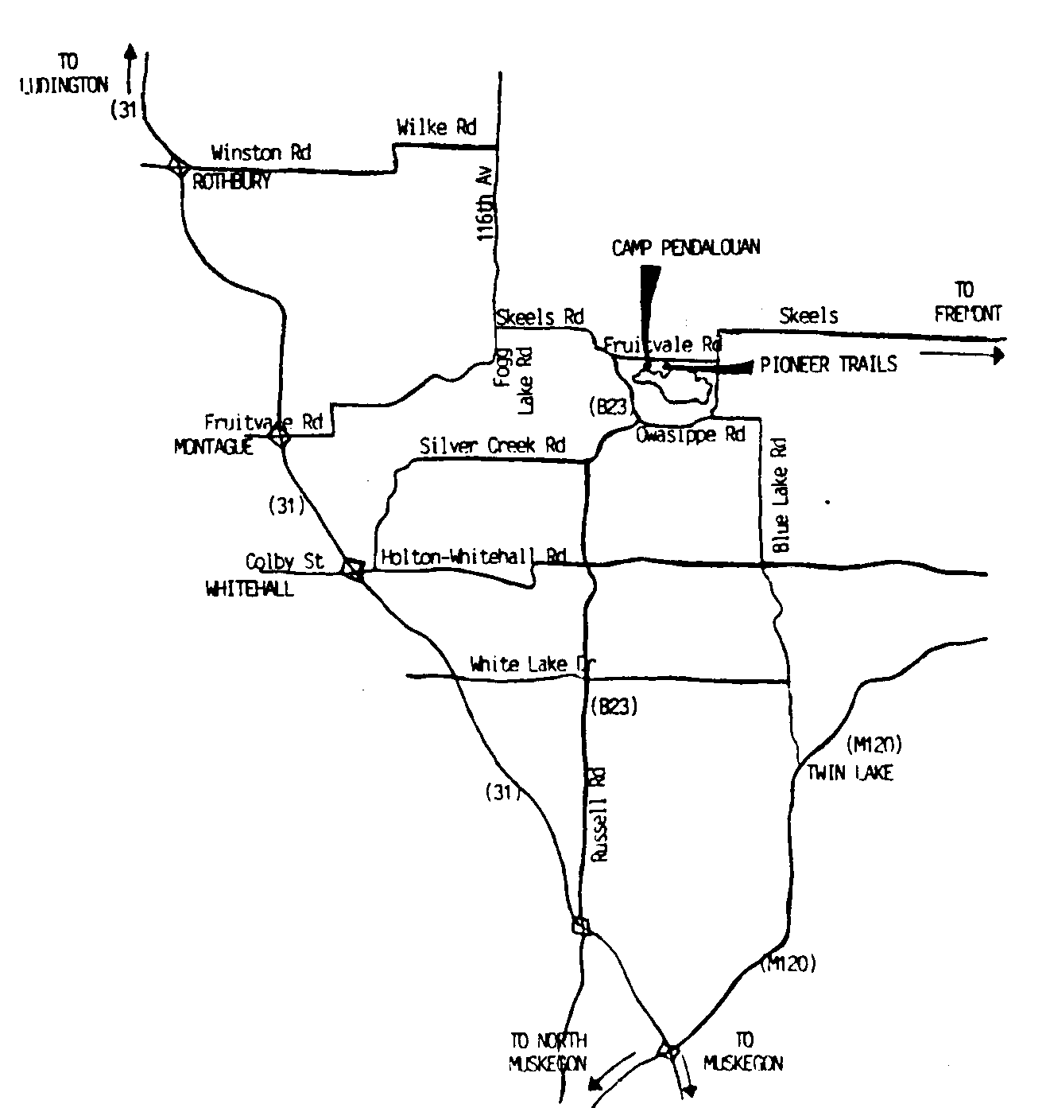
From the South
- Take I-96 West to U.S. 31 North (Muskegon).
- Take the RUSSELL ROAD exit. (Approx. 6 miles North of the Apple Ave. exit).
- Turn Right onto Russell Road.
- Follow Russell all the way until it ends. About 10 miles. (Russell Road twists and turns, be sure to follow the signs for Muskegon County B-23).
- Russell Road will end at FRUITVALE ROAD.
- Take a right onto Fruitvale Road. Go 1/2 mile, Camp Pendalouan is on the right.

